District Cardiac Emergency Response Protocol
Geneva Community School District 304
The School Safety Drill Act now requires school districts to develop and implement a Cardiac Emergency Response Plan (CERP) to address the use of school personnel in responding to incidents of sudden cardiac arrest or similar life-threatening emergencies at school or during school-sponsored activities or events. Sudden cardiac arrest events can vary greatly and immediate action is crucial.

Follow these steps when responding to a suspected cardiac emergency:
1) Recognize the signs of sudden cardiac arrest and act quickly in the event of one or more of the following:
a. The person is not moving, unresponsive, or unconscious.
b. The person is not breathing normally (has irregular breaths, gasping or gurgling, or is not breathing at all).
c. The person appears to be having a seizure or is experiencing convulsion-like activity. Cardiac arrest victims commonly appear to be having convulsions.
d. If the person received a blunt blow to the chest, this can cause cardiac arrest, a condition called commotio cordis. The person may have the signs of cardiac arrest described above and is treated the same.

2) Facilitate immediate access to medical help:
a. Call 9-1-1 as soon as you suspect a sudden cardiac arrest.
b. Immediately contact the members of the Cardiac Emergency Response Team (CERT) and/or building administration using your building’s designated communication system (i.e. walkie talkies, overhead page, phone, ect...)

3) Start cardiopulmonary resuscitation (CPR):
a. Begin continuous chest compressions.

4) Use the nearest automated external defibrillator (AED):
a. Bring AED is brought to the patient’s side, press the power-on button, and attach the pads to the patient as shown in the diagram on the pads.
b. Then follow the AED’s audio and visual instructions. If the person needs to be shocked to restore a normal heart rhythm, the AED will deliver one or more shocks.

5) Transition care to Emergency Medical Services (EMS).

6) Consider additional action that may need to be taken by administrative staff or designee (i.e. management, resource allocation)

7) Debrief and/or Post- Event Support

In accordance with Public Act 103-608 (Cardiac Emergency Response Plan) Geneva 304 has develop a Cardiac Emergency Response Plan (CERP) for each school in accordance with guidelines set forth by either the American Heart Association or other nationally recognized, evidence-based standards that addresses the appropriate response to incidents involving an individual experiencing sudden cardiac arrest or a similar life-threatening emergency while at a school or at a school-sponsored activity or event. This Act requires that the building’s plan must be distributed to all teachers, administrators, school support personnel, coaches, and other school staff.

The Cardiac Emergency Response Plan (CERP) includes:
1. Procedures to follow in the event of a cardiac emergency at a school.
2. A listing of every automated external defibrillator that is present and clearly marked or easily accessible at school athletic venues and events and at school and the maintenance schedule for the automated external defibrillator.
3. Information on hands-only cardiopulmonary resuscitation and use of automated external defibrillators.

Please reach out to your school’s Certified School Nurse or the Safety and Security Coordinator with any questions.

APPENDIX
- Appendix 1: Basic Life Support Actions
- Appendix 2: AED Quick Guide
- Appendix 3: AED Maintenance

APPENDIX 1: Basic Life Support Actions
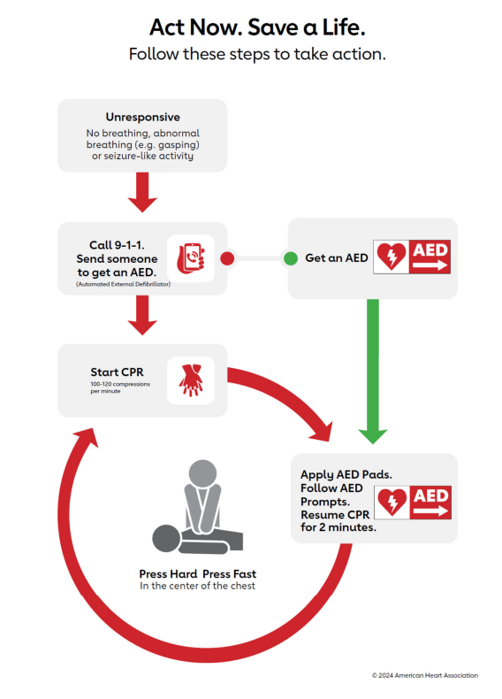
APPENDIX 2: AED Quick Guide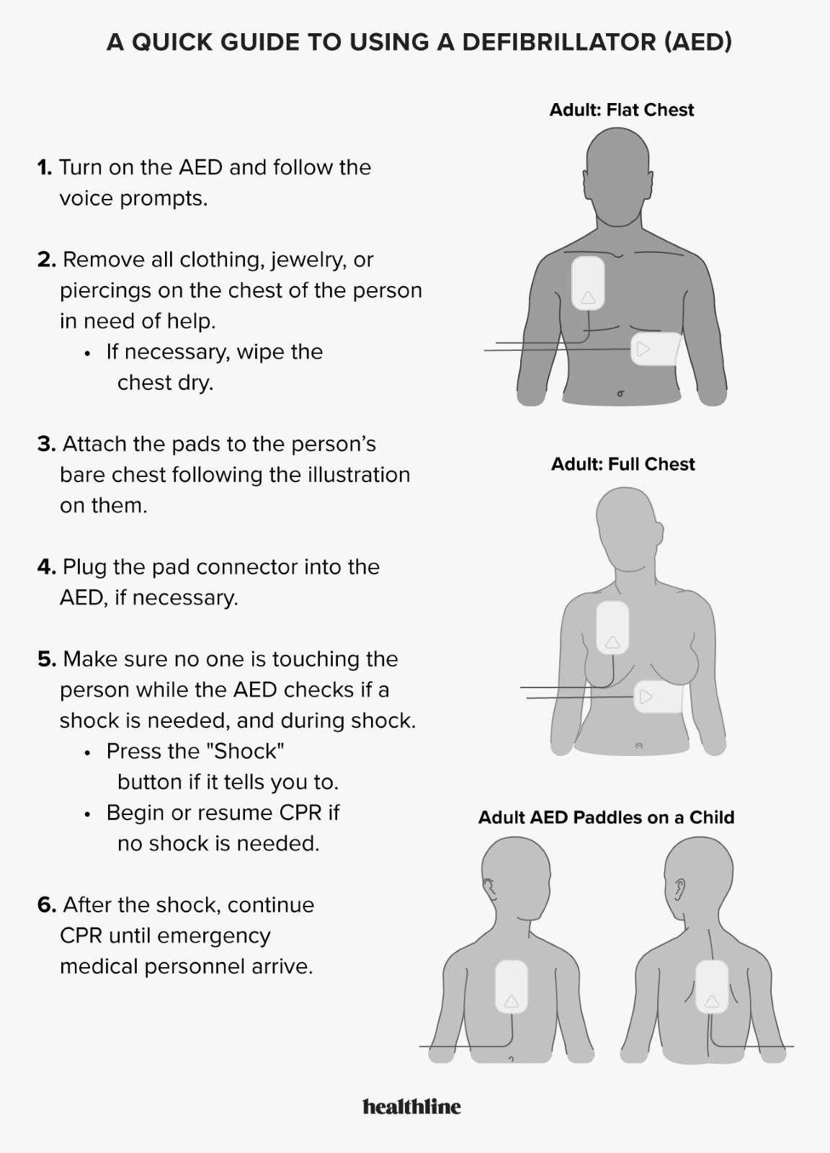APPENDIX 3: AED Maintenance
Reports of Damage. Follow the manufacturer’s recommendations for all scheduled AED maintenance checks. Report any performance discrepancies, device defects, or missing, expired, and/or damaged accessories to the Safety and Security Coordinator immediately.
Monthly Maintenance Schedule. Refer to the maintenance schedule in the AED User’s Guide, which also provides detailed instructions for responding to each maintenance task.
Cleaning. When necessary, clean the AED using recommended cleaning agents, according to AED User’s Guide.

